Lambda Expression VS Anonymous class
Anonymous Inner Class: (Inner class with no name)
I am writing a class that implements Runnable interface. For that runnable implemented class, we creating a new object. Here it is the object of a class which implements Runnable interface and there is no name of the class. If the implementation class having no name, then it is called anonymous inner class.
Ex:
Runnable r=new Runnable(){
Public void run(){
}
}

Wherever anonymous class is there, then it can be replaced by lambda expression. But all anonymous classes is not replaced by lambda. Lambda expression is not meant for replacing anonymous classes.

Where anonymous class can be replaced by lambda expression:

If the anonymous inner class implements an interface which contains only one abstract method, then only it can be replaced by lambda expression.

Anonymous inner Class extends Concrete class.  Class Test{  }  Test t=new Test(){  } | Anonymous inner Class extends Abstract class.  abstract class Test{  }  Test t=new Test(){  }
Anonymous inner Class implements interface which contains multiple abstract methods.  Interface Test{  Public void m1();  Public void m2();  Public void m3();  }  Test t=new Test(){  Public void m1(){}  Public void m2(){}  Public void m3(){}  } | Anonymous inner Class implements interface which contains only one abstract method (functional interface).  Interface Test{  Public void m1();  }  Test t=new Test(){  Public void m1(){}  }  Note: Only here, the anonymous inner class which implements a functional interface, then only it can be replaced by lambda expression.

Note:
In the Anonymous Inner Class, this always refer current inner class instance only.
In the Lambda Expression, this always refers the outer class instance. Because for lambda expression, there is no object storage.

Inside Anonymous Inner Class, we can declare instance variable but not in lambda. The variables declared in lambda expression is treated as local variable only.

Example using anonymous inner class:
Output: 999
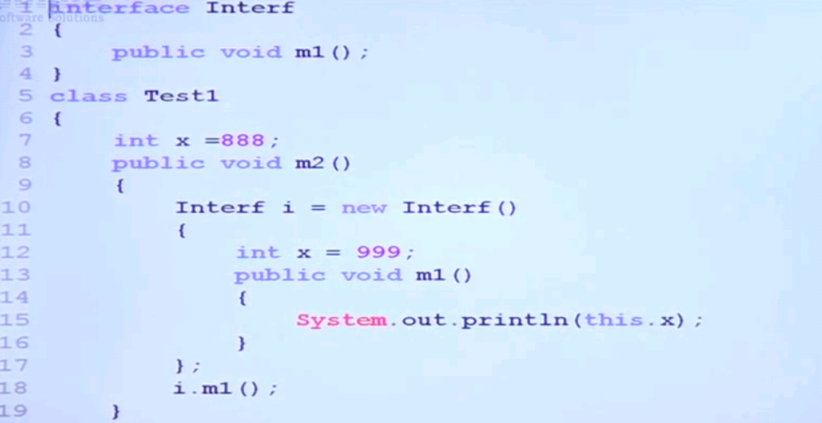

Example using lambda expression which replaces above anonymous inner class:
In lambda expression, x is treated as local variable only not instance variable. Also this refers to outer class instance only.
Output: 888

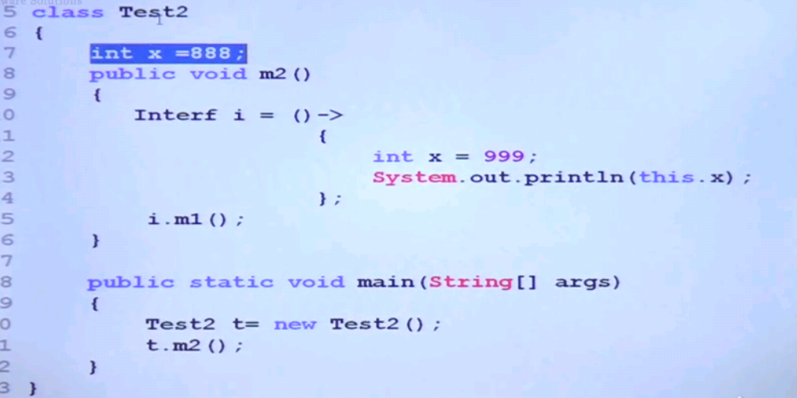

Differences b/w lambda and anonymous inner class:
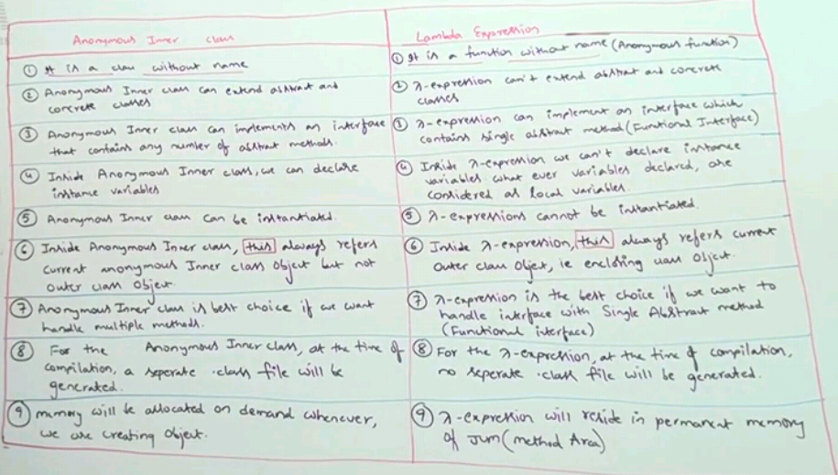

Note:
Inside lambda expression, we can access enclosing method variable and class variables directly.

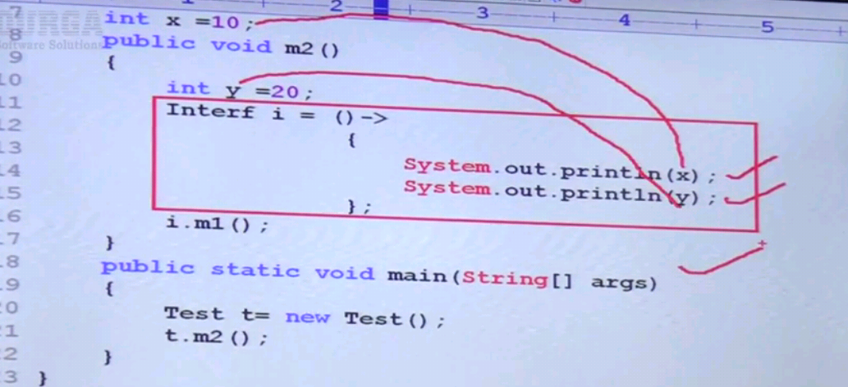

Important: The local variables of the method which are referenced from lambda expression is implicitly becomes final because this lambda expression is going to execute from somewhere so the local variables are become final implicitly.

- The local variables(method level) referenced from lambda expression must be effectively final.
Once the local vaiables is used in lambda expression, then it becomes final, so it is not allowed to change in lambda expression.
We can change the instance variables in lambda but not local variables.

